FTF FY 2023 Performance Scorecard USAID Honduras

This Feed the Future (FTF) Performance Scorecard assesses the USAID Honduras progress toward FY 2030 Performance Targets.

# Performance Overview



The FY 2023 **On track** value is determined by drawing a line from the baseline (FY 2022) to the FY 2030 Target. For FY 2023, Performance Targets are considered **On track** if they have reported at least 90% of that value.

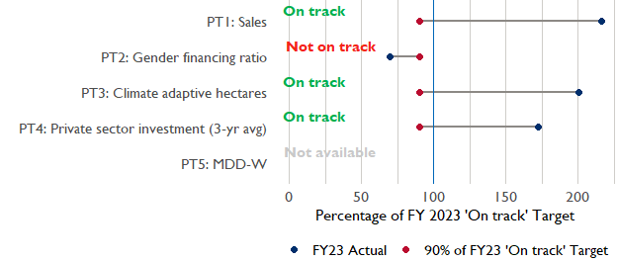

**Note:** *For Performance Target 2 (Gender financing ratio), the target is to increase financing to females for those OUs that are already achieving parity ($1).*

*For Performance Target 4 (PSI), all targets are relative to the last three years’ reporting. In future years, the interim targets may increase.*

*For Performance Target 5 (MDD-W), all FY23 actual values are also the baseline, and may have been collected in a prior year. See the detail page for more information.*

*See detailed* [*methodology document*](https://docs.google.com/document/d/13n-43ppFiGKauscQ7HaAiQDCM4DssGEgRdq2fMyTDn0/edit) *here. If you have questions, please email the FTF Data and Analytics team at* [refs.adl.da@usaid.gov](mailto:refs.adl.da@usaid.gov).

### Performance Target (PT) Details

This section shows PT scores for each applicable PT for USAID Honduras.

## Performance Target 1: Value of annual sales of producers and firms receiving USG assistance



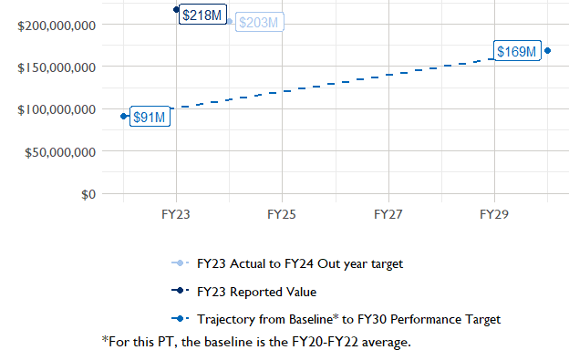

In FY 2023, USAID Honduras had 3 activities that aligned the ‘Value of annual sales from producers and firms receiving USG assistance’ (EG.3.2-26), and 3 contributed to the sales total of $217,780,000.

###### Performance Target 2: Value of financing accessed by female FTF participants per $1 of financing accessed by male FTF participants



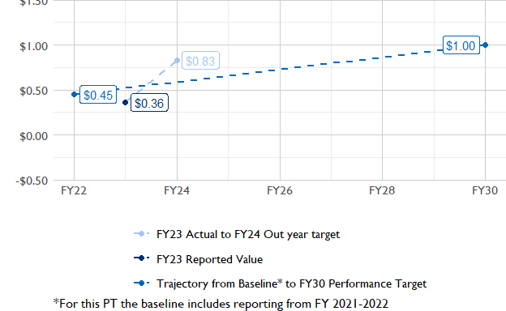

In FY 2023, USAID Honduras had 3 IMs/Activities that reported all four sex disaggregates needed to contribute to PT2. The total value of financing among all activities, regardless of disaggregates, was $24,510,000 (EG.3.2-27 total), with $24,510,000 that was disaggregated by females and males, and an additional $14,330,000 to ‘mixed’ firms that have both males and females, and $1,060,000 that was not sex disaggregated.

###### Performance Target 3: Number of cultivated hectares under climate adaptation/climate risk management practices and technologies with USG assistance



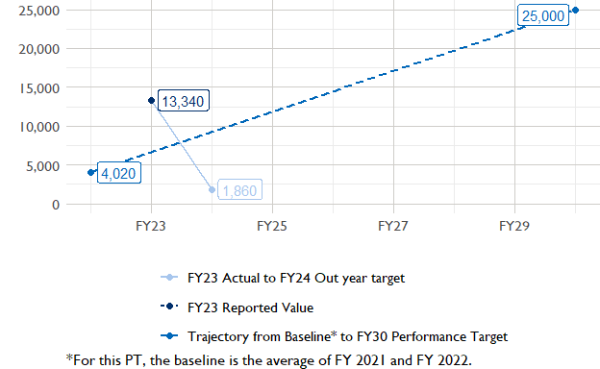

In FY 2023, Honduras had 8 activities that aligned the indicator for hectares under improved management practices (EG.3.2-25). Of those activities, 1 reported on the ‘Climate adaptation/climate risk management’ disaggregate and contributed to the OU total for this PT.

###### Performance Target 4: Value of private sector investment leveraged by the USG to support food security and nutrition



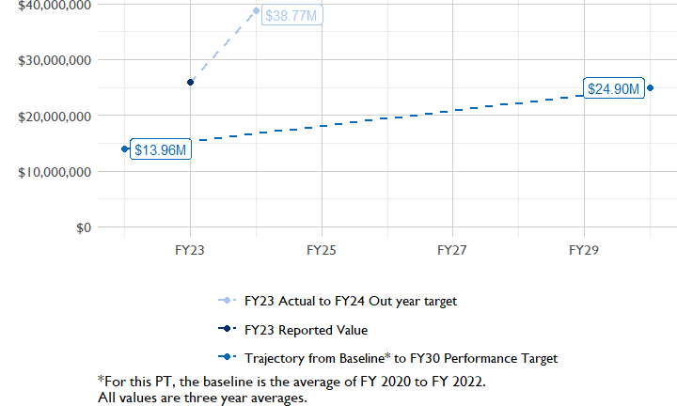

In FY 2023, Honduras had 2 activities that aligned the private sector investment indicator (EG.3.1-15/-14), ‘Value of new private sector investment leveraged by the USG to support food security and nutrition [IM-level]’, and 2 contributed to the OU total in FY 2023.

###### Performance Target 5: Percent of women consuming a diet of minimum diversity (MDD-W)



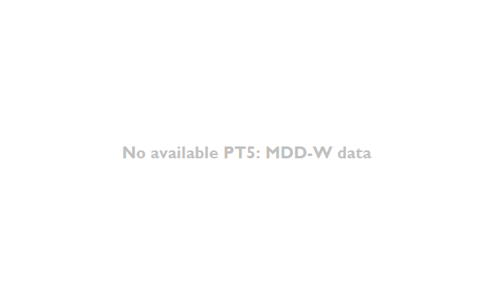

PT5 is not available for USAID Honduras.

### National Context

National level data was collected from the [World Bank’s Open Data portal](https://data.worldbank.org/) that measures key indicators at the national level.

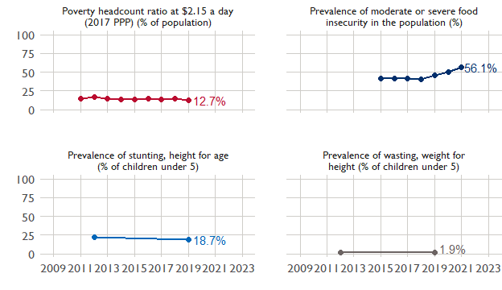

## Agricultural Transformation Index Score

The IFPRI Agricultural Transformation Index (ATI) Score is a high level indicator of the status of agricultural market systems in each country.

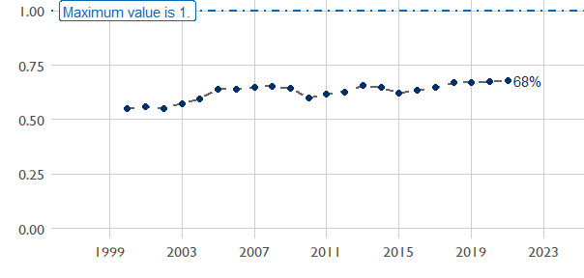

## Budget Trend

At the Operating Unit level, the Performance Targets are based in part on the FY 2024 budget request. The budget chart below includes EG.3 money only.

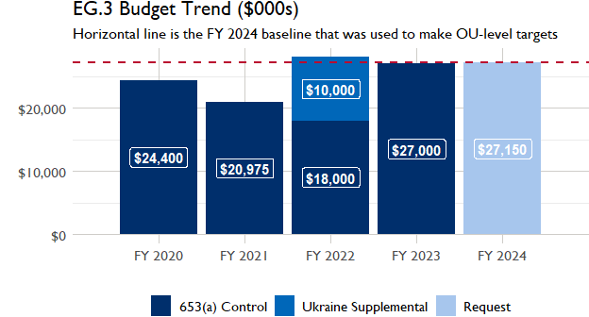

## Active Portfolio

The following activities are considered “active” based on their reporting in FY 2023 and expected FY 2024 reporting. The Analytics, Data and Learning Division defines an “active” activity as one that reported targets, actuals, or deviation narratives for the current year (FY 2023), or the next out year targets (i.e. FY 2024).

## Top Activities (Award Disbursements and Results)

This section highlights the 5 activities (out of the total 8 in the USAID Honduras (HONDURAS) portfolio) that have the highest level of FY 2023 annual disbursements and highest reported values for the relevant indicators. The first table below shows activities with the highest total transaction amounts. The columns to the right indicate if these activities are reporting on relevant PT indicators.

| Award Number | Activity Code | Activity Name | FY23 Disbursements | PT1 | PT2 | PT3 | PT4 |
| --- | --- | --- | --- | --- | --- | --- | --- |
| 72052222C00001 | 4597 | Feed the Future Honduras Food Security, Agriculture, and Resilient Market Systems (FARMS) | $7,055,531 | X | X | - | X |
| 72052218D00001 | 1280 | Transforming Market Systems Activity | $2,519,442 | X | X | - | X |
| 72052222CA00001 | 5917 | Creating Rural Opportunities and Prosperity in Agriculture for a Resilient Future | $1,069,128 | - | - | - | - |

The next table (below) shows the activities that reported the highest values for the relevant PT indicators. The total disbursements are included, if available.

| Award Number | Activity Code | Activity Name | Total Disbursements | Sales | Hectares | PSI |
| --- | --- | --- | --- | --- | --- | --- |
| 72052218CA00001 | 1275 | Building Resilience through Markets and Sustainable Coffee Production in Western Honduras | NA | $90,260,580 | 13 343 | NA |
| 72052222C00001 | 4597 | Feed the Future Honduras Food Security, Agriculture, and Resilient Market Systems (FARMS) | $7,055,531 | $72,272,675 | NA | $8,523,667 |
| 72052218D00001 | 1280 | Transforming Market Systems Activity | $2,519,442 | $55,248,859 | NA | $28,782,232 |
| 72052222CA00001 | 5917 | Creating Rural Opportunities and Prosperity in Agriculture for a Resilient Future | $1,069,128 | NA | NA | NA |
| !! Not reported !! | 1273 | Alliance for the Dry Corridor | NA | NA | NA | NA |

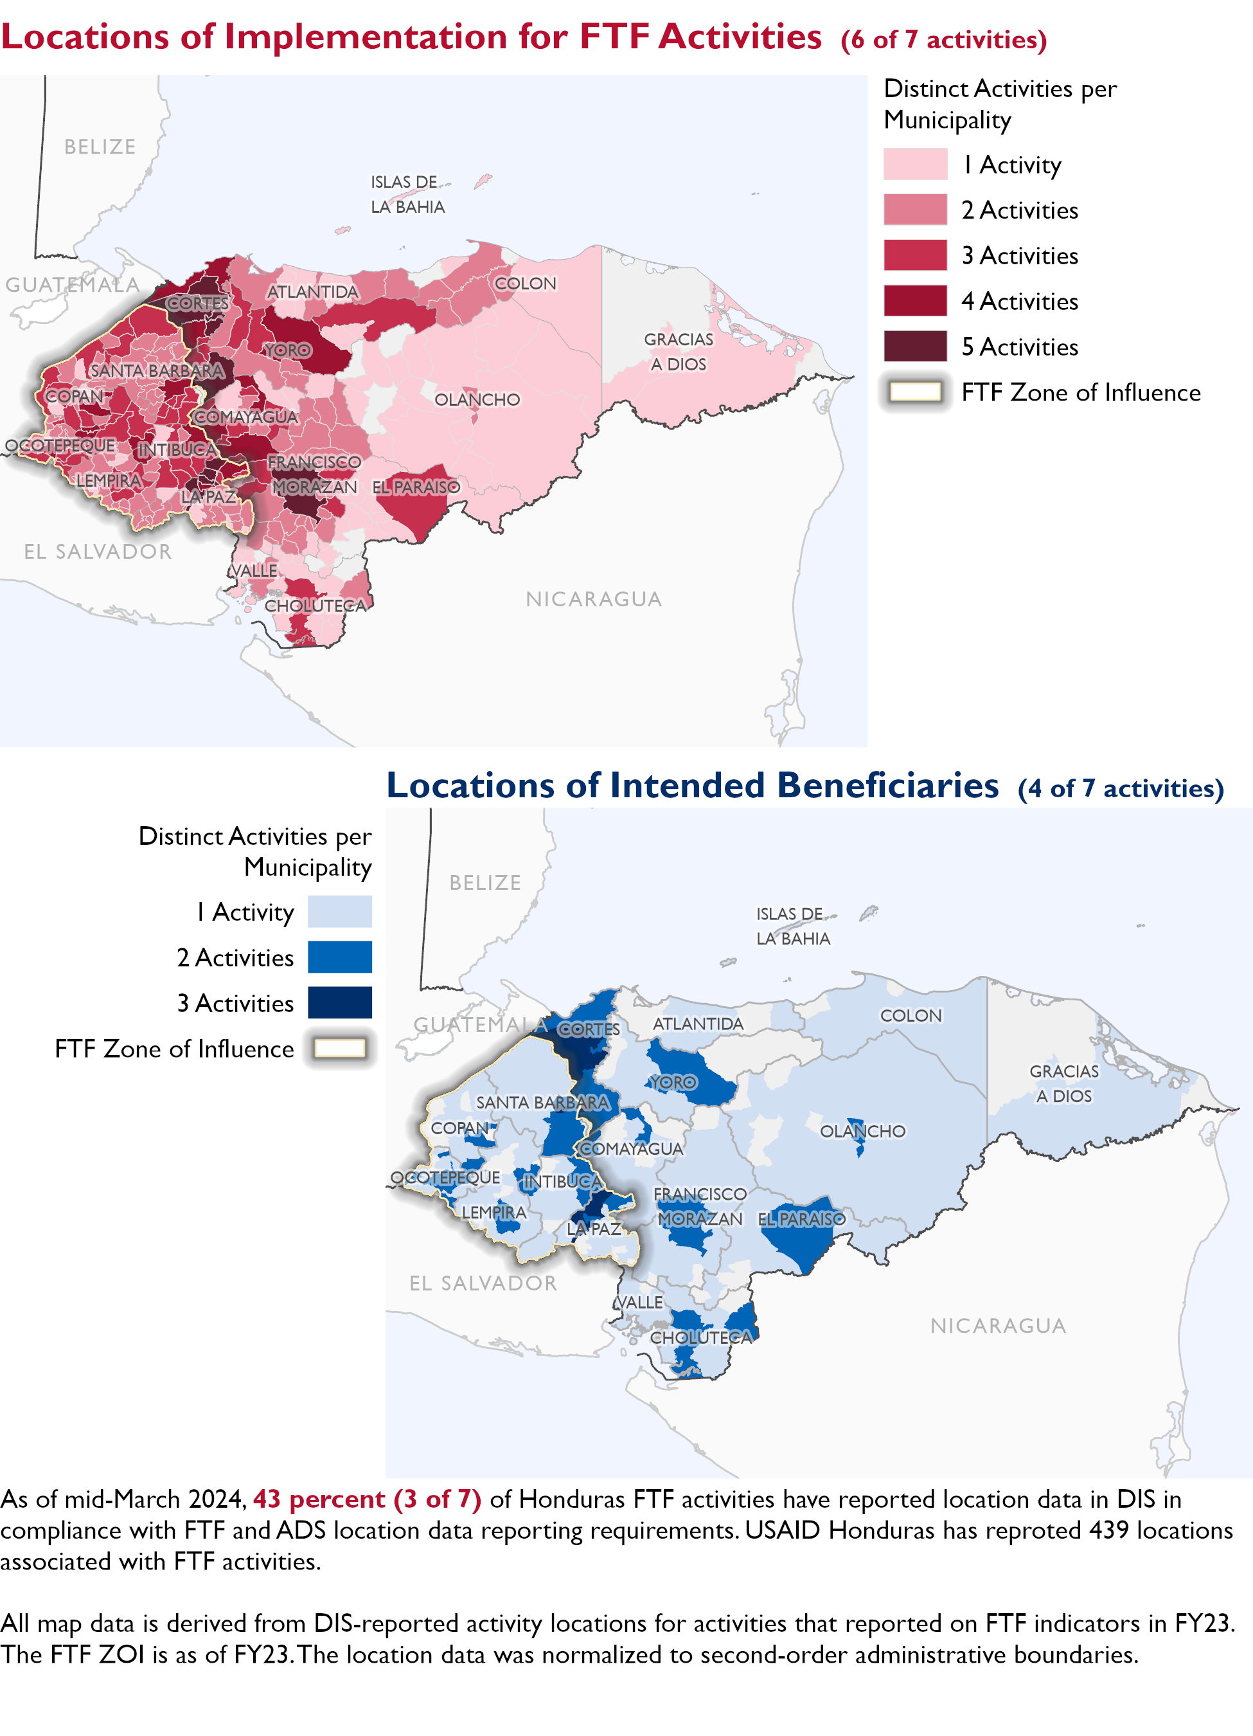

### Appendix 1: Response to “Not on track” Performance Targets

This section provides space for USAID Honduras to provide an explanation of why the following PTs are not on track and how you could adjust to be on track in the coming year(s). To help in your response(s), the relevant section of the FTF/GFS Key Issue Narrative (KIN) is provided, as it *may be* useful in drafting a responses. Note that the KIN is addressing the sum of the out year targets (FY 2023) set by the USAID Honduras activities that are reporting on each PT. The FY 2023 out year targets were set prior to the establishment of the FY 2030 Performance Targets, so the below explanations from the KIN may not apply to the Performance Target deviation.

* In Section 4 of the FTF KIN, your OU discusses FY24 and FY25 targets, while these Scorecards are addressing progress against a trajectory from historical reporting to your OU’s FY30 target. Also, the FY 2023 out year targets were set prior to the establishment of the FY 2030 Performance Targets. Therefore, the below explanations from the KIN may not apply to these FY30 Performance Target deviations.
* These responses will be used to compile a Congressional report, the GFSS Implementation Report, to discuss progress against the FTF FY 2030 Performance Targets, as mandated by the GAO.
* Only PTs that are ‘Not on Track’ require review and explanation from the OU.

Include in the response:

1. An explanation of why this target is not on track. Explanations may include that the OU/Mission was not aware of the target prior to planning activities.
2. Planned actions for ‘not on track’ targets. Planned actions may include the launch of new activities, building awareness, holding portfolio reviews, or other suggestions.

## Performance Target 2: Gender financing ratio [Not on Track]

*Excerpt from FY23 KIN Section 4 to consider:* ’ FTF-funded activities surpassed their FY 2023 targets for the value of agriculture-related financing, but fell short in increasing the value of financing accessed by women. The Mission’s activities targeted $0.38 of finance to women for every dollar financed to men and achieved 40 percent of this target. While USAID/Honduras’ FTF programs did enhance women’s access to agricultural financing, the loan sizes remained smaller compared to those for men. Women accessed only $0.15 per dollar obtained by men, indicating the overall smaller value of loans to women. This pattern aligns with lessons from previous FTF activities, where women typically start with smaller loans that increase over time as they build their working capital during their participation in USAID’s activities. The TMS Activity is more advanced in implementation and successfully boosted the proportion of female beneficiaries who accessed financing to 36 percent, securing $0.18 of financing for every dollar financed to men. Similarly, 33 percent of the Coffee Alliance Activity’s beneficiaries who accessed finance were women and they secured $0.13 of financing for every dollar financed to men. In its second year of implementation, 46 percent of FARMS beneficiaries who accessed finance were women, but the value of their financing was $0.07 for every dollar financed by men. These results align with the Mission’s FTF programming objective to expand women’s access to productive resources and credit. However, women still encounter various challenges related to the financial system’s eligibility criteria (such as land ownership, collateral, etc.), which requires continued attention. Based on FY 2023 results, there’s a need to revise FY 2024 and FY 2025 targets and explore opportunities to enhance the implementation strategy to accelerate the growth of loan sizes for women.

#### Enter USAID Honduras (HONDURAS) response below: